Visualizations

Clarentia Kurnia

4/16/2022

#Libraries

#install.packages("ggplot2")  
#install.packages("tidyverse")  
#install.packages("readr")  
library(ggplot2)  
library(tidyverse)

## ── Attaching packages ─────────────────────────────────────── tidyverse 1.3.1 ──

## ✓ tibble 3.1.3 ✓ dplyr 1.0.7  
## ✓ tidyr 1.2.0 ✓ stringr 1.4.0  
## ✓ readr 2.1.2 ✓ forcats 0.5.1  
## ✓ purrr 0.3.4

## Warning: package 'tidyr' was built under R version 4.1.2

## Warning: package 'readr' was built under R version 4.1.2

## ── Conflicts ────────────────────────────────────────── tidyverse_conflicts() ──  
## x dplyr::filter() masks stats::filter()  
## x dplyr::lag() masks stats::lag()

library(readr)

#Data

url <- "https://raw.githubusercontent.com/fivethirtyeight/data/master/alcohol-consumption/drinks.csv"  
  
drinks <- read_csv(url(url))

## Rows: 193 Columns: 5

## ── Column specification ────────────────────────────────────────────────────────  
## Delimiter: ","  
## chr (1): country  
## dbl (4): beer_servings, spirit_servings, wine_servings, total_litres_of_pure...

##   
## ℹ Use `spec()` to retrieve the full column specification for this data.  
## ℹ Specify the column types or set `show_col_types = FALSE` to quiet this message.

This scatterplot shows the range of alcohol consumed by more than 100 countries around the world. We have countries that consume no alcohol at all, while some others consume nearly 15 litres of alcohol.

#Scatterplot 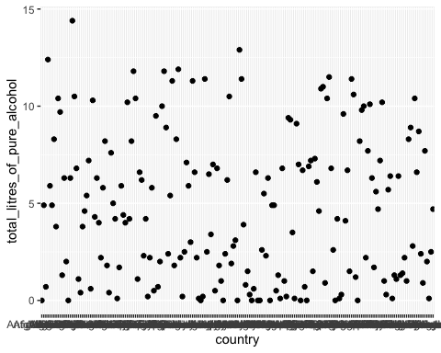

This bar chart shows the top 3 countries which consume the most alcohol. In order, Belarus drinks the most, followed by Lithuania, then Andorra.

#Bar chart 